**Unit Testing of SHAW OM PointOfSales From Cloud to DBCS**

**And SHAW OM PointOfSales From DBCS to Logfire**

**Process to create test data**

**Query to get the Serial numbers which are in issued out of stores status of a particular org in ERP:**

SELECT

iop.organization_code,

sib.item_number,

isn.current_subinventory_code,

fl.meaning serial_status,

isn.serial_number,

isn.lpn_id,

isn.last_update_date,

isn.last_updated_by,

isn.creation_date,

isn.created_by

FROM

inv_serial_numbers isn,

inv_org_parameters iop,

egp_system_items_b sib,

fnd_lookups fl

WHERE

fl.lookup_type = 'INV_SERIAL_NUM_STATUS'

AND isn.current_status = fl.lookup_code

AND isn.current_organization_id = iop.organization_id

AND isn.current_organization_id = sib.organization_id

AND isn.inventory_item_id = sib.inventory_item_id

AND isn.last_update_date =

(

SELECT

Max(last_update_date)

FROM

inv_serial_numbers

WHERE

serial_number = isn.serial_number

)

AND iop.organization_code = 'CGY'

AND fl.meaning LIKE 'Issued out%'

ORDER BY

isn.serial_number;

* Select some transactions from the above query and receive it manually through ERP application

**Step 2:** To receive the serials in ERP follow the Navigation

* **Supply Chain Execution>Inventory Management>Create Miscellaneous Transaction**

**Enter Organization**

**Transaction_Type**: Shaw Project Receipt

**Account**: 200.0000.15010.051999.0000.00000.000000.000

* Enter Item Number, Sub inventory, Quantity
* Click the Records lots and serial numbers tab and enter the serial numbers in **enter single serial number** tab

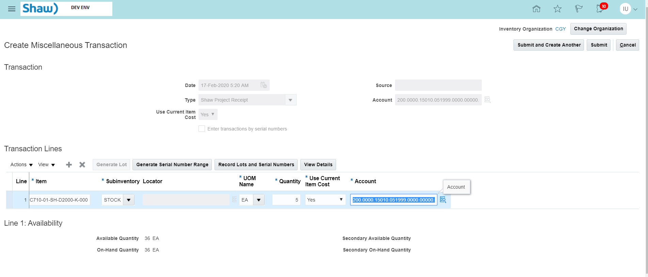

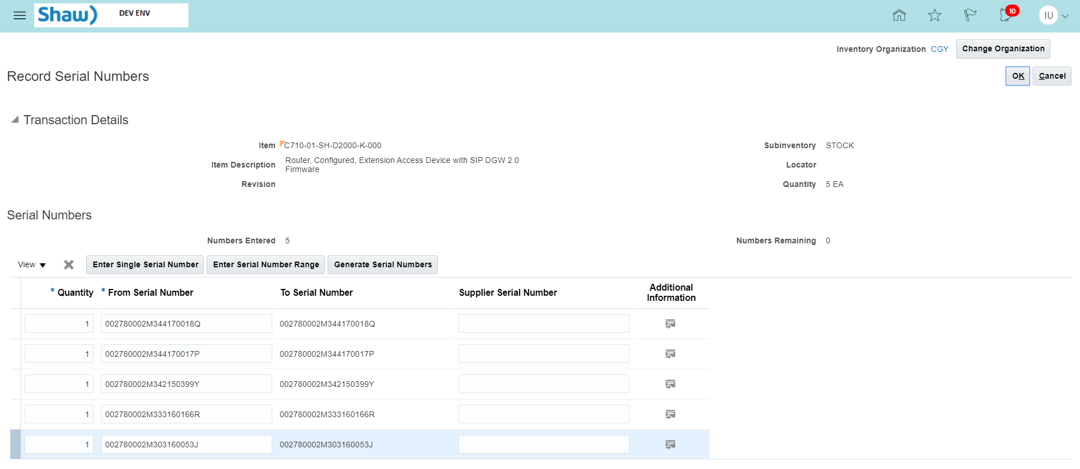



Click Ok button

Click View Details





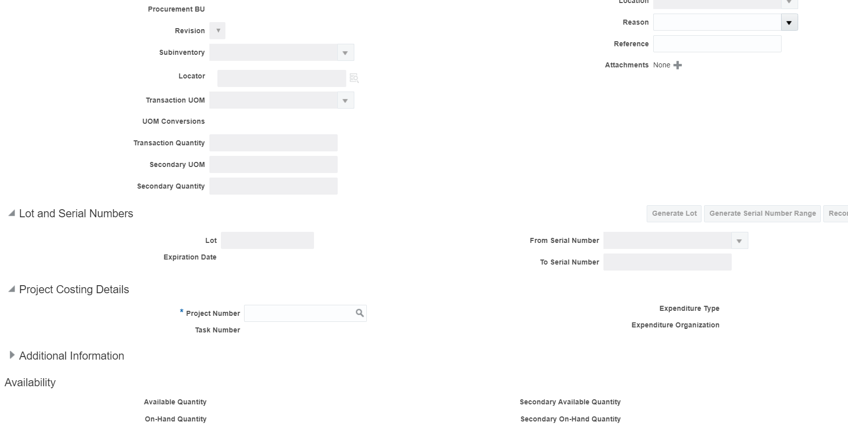

To get the **Active Project Number and Task Number** run the below query in cloud ERP

select

'''' || a.segment1 || '|' || b.task_number || ''',',

a.project_status_code,

a.segment1,

b.task_number,

b.CHARGEABLE_FLAG,

case

when

b.completion_date > sysdate

then

'Active'

else

'Inactive'

end

Task_Status

from

pjf_projects_all_vl a, pjf_tasks_v b

where

a.project_id = b.project_id

and a.project_status_code = 'ACTIVE'

and b.CHARGEABLE_FLAG = 'Y'

and b.completion_date > sysdate;

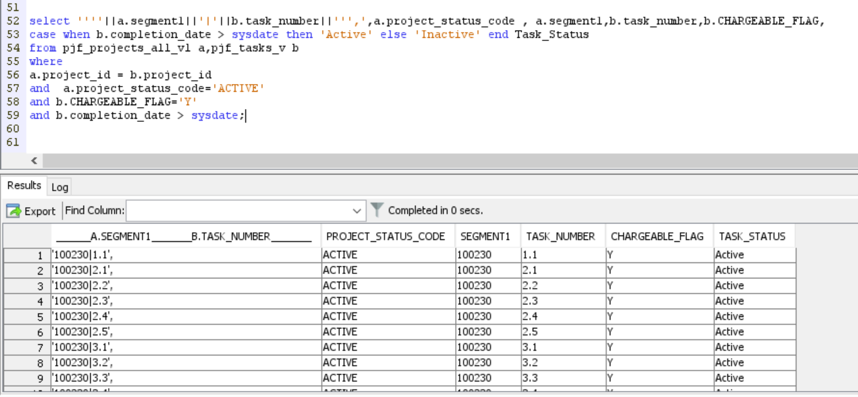

**Enter Active Project Number ,Task Number ,Expenditure Organization : Accounting**

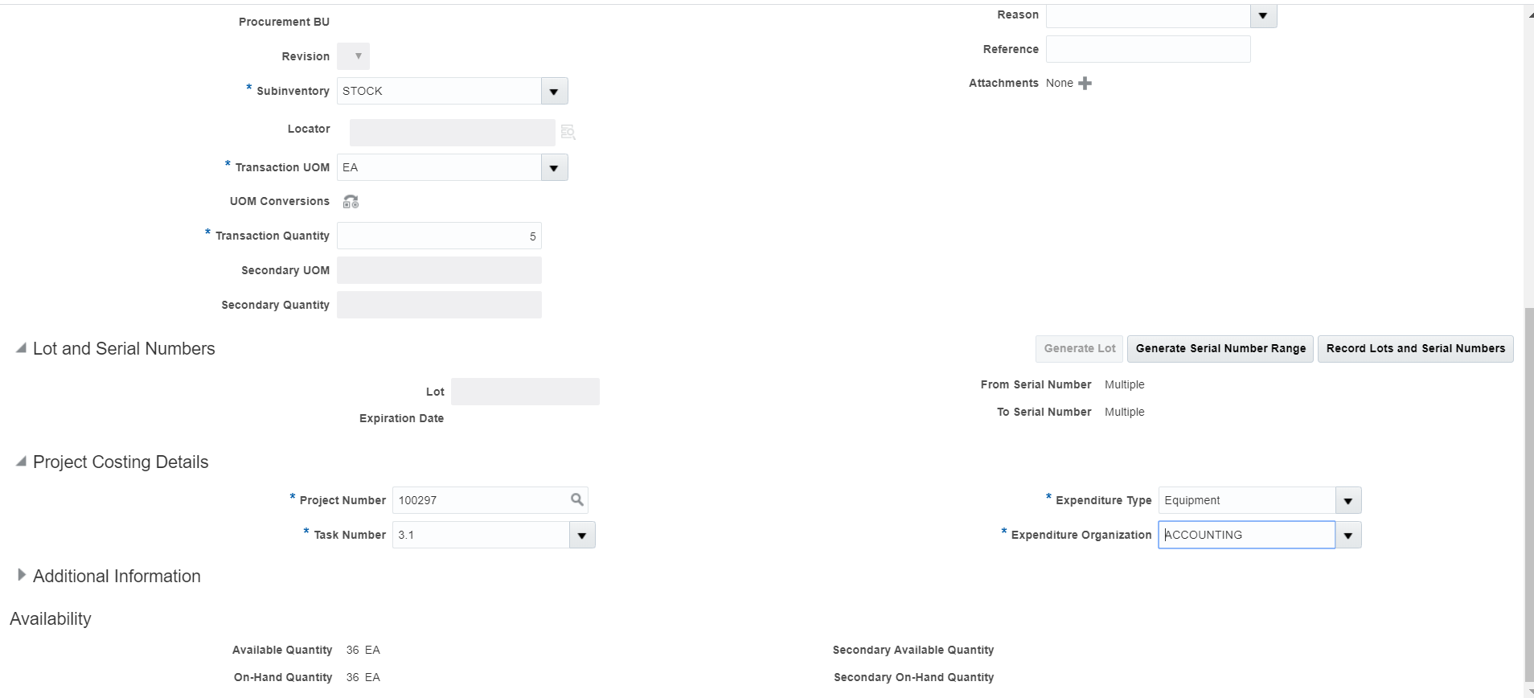

**CLICK OK BUTTON**

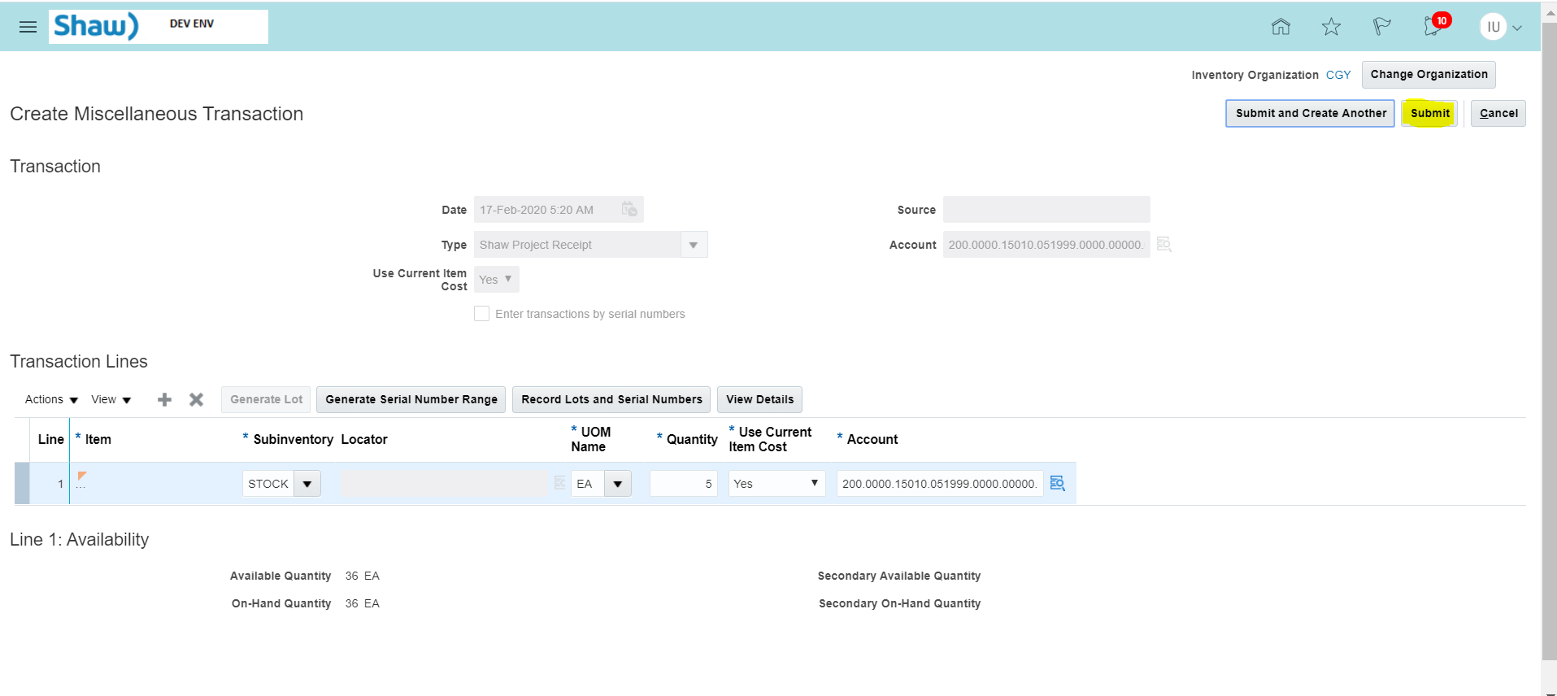

**Click Submit button.**

**After creating test data using above process, Check the Status of serial numbers in ERP.**

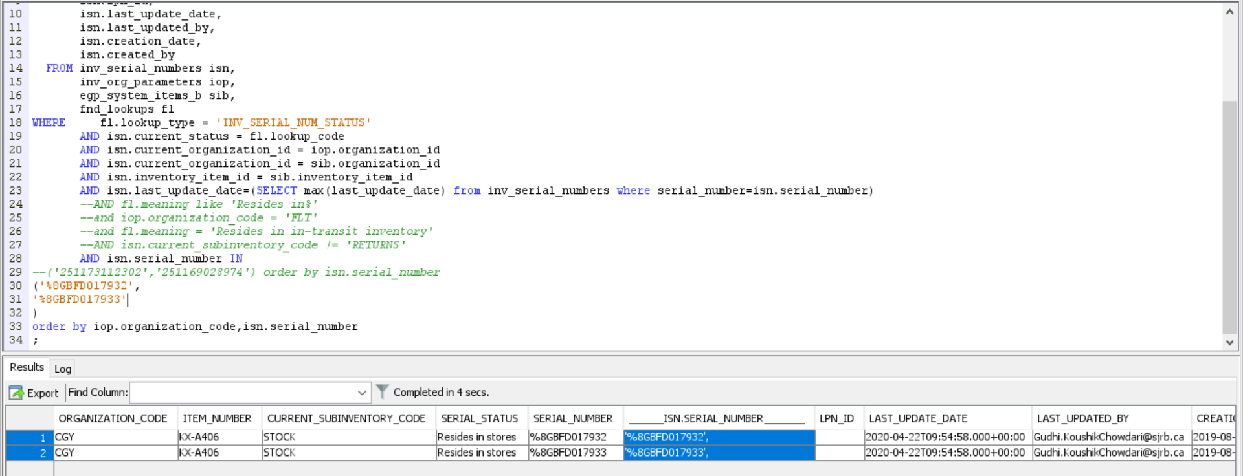

Now , the serial numbers are received in ERP.

Run Details:-

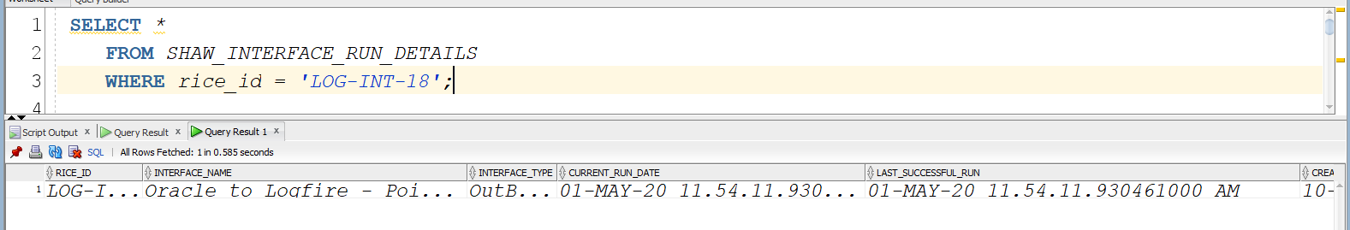

New Records in staging before integration run

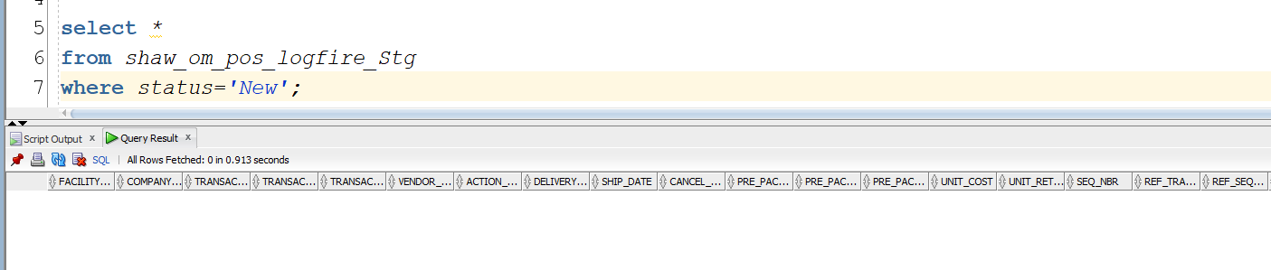

Run the integration “SHAW OM PointOfSales From Cloud to LogFire”

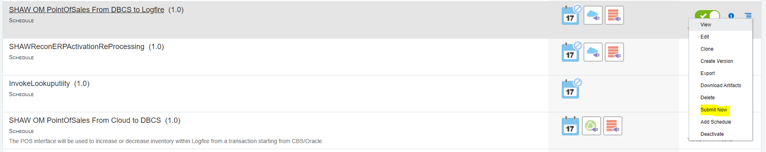



Run Details had been changed:

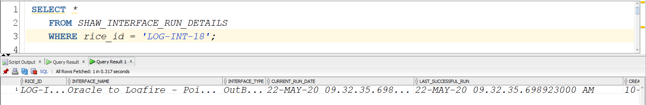

Data in Staging:

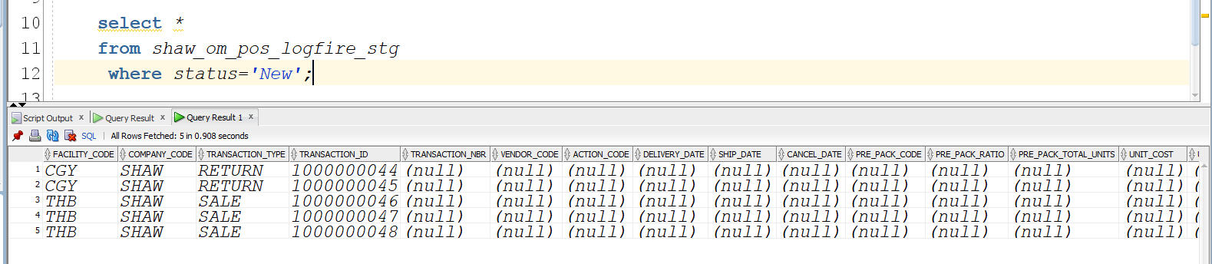

Tracking in ICS:

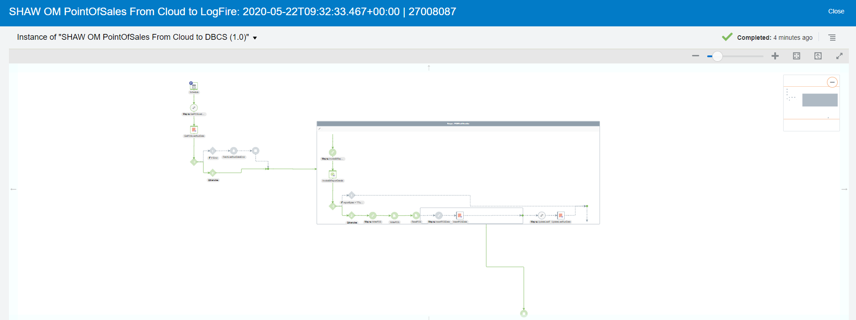

**Testing for BULK Project Transaction Issue**

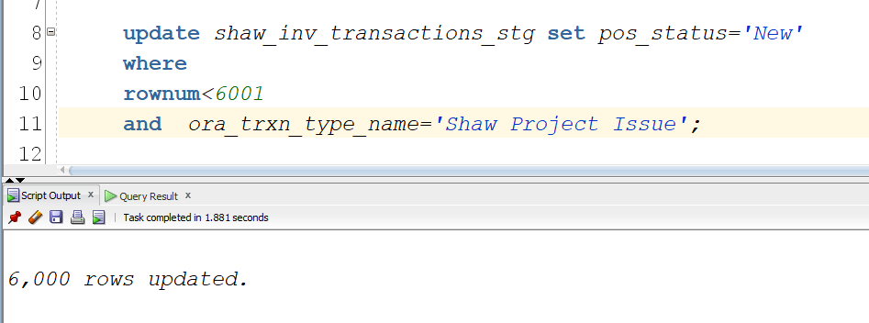

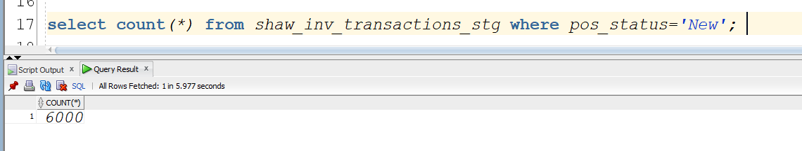

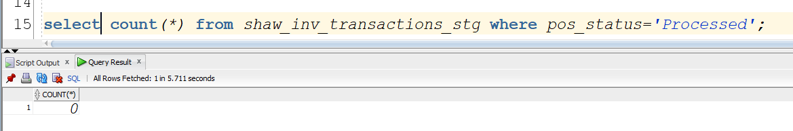

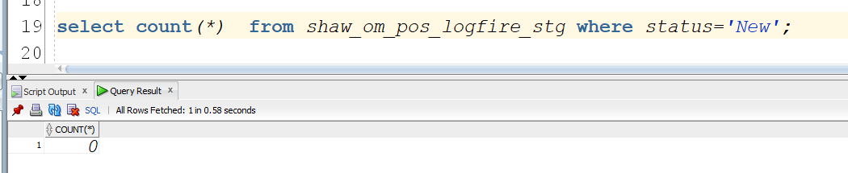

**Submit Integration**

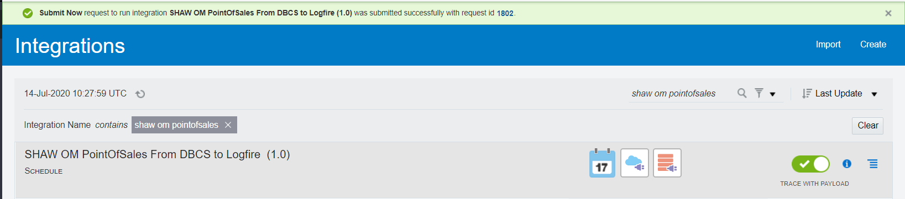

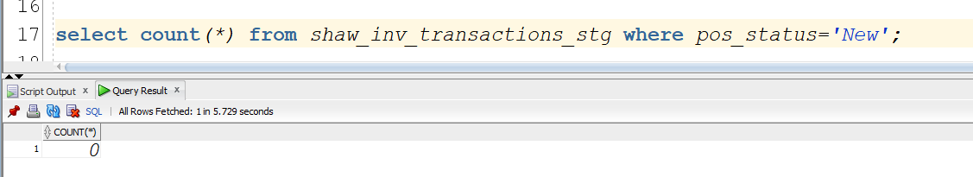

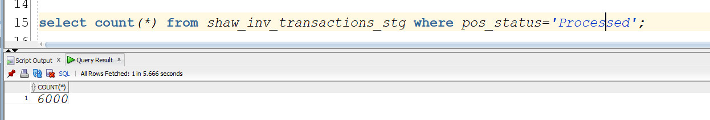

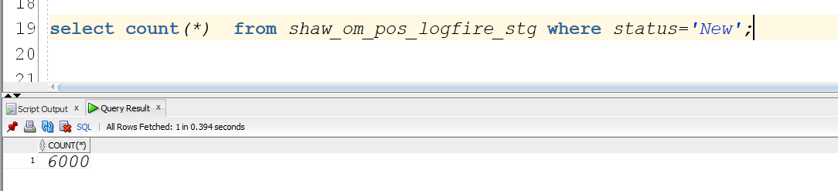

WMS API Call is not working due to hand shake issue failure as you could see the project issue transactions got inserted into pos staging table and stuck in New status.